**Automated Hydroponic Cattle Feed Generator**



CEP Report

By

|  |  |
| --- | --- |
| NAME | Registration Number |
| Sheikh Ata Ur Rehman Saqib | CUI/FA22-BCE-061 /ATD |
| Syed Iftikhar Shah | CUI/FA22-BCE-057 /ATD |
| Sahibzada Daniyal | CUI/FA22-BCE-082 /ATD |

**CPE-342 Microprocessor Systems & Interfacing**

Semester Spring 2025

Supervised by: Muhammad Naveed Shaikh

CEP Course Teacher’s Name: Muhammad Naveed Shaikh

Department of Computer Engineering

COMSATS University Islamabad – Abbottabad Campus

**DECLARATION**

We Sheikh Ata Ur Rehman Saqib (CUI/FA22-BCE-061/ATD), Syed Iftikhar Shah (CUI/FA22-BCE-057/ATD) and Sahibzada Daniyal (CUI/ FA22-BCE-082/ ATD) hereby declare that we have produced the work presented in this report, during the scheduled period of study. We also declare that we have not taken any material from any source except referred to wherever due. If a violation of rules has occurred in this report, we shall be liable to punishable action.

Date: 20 July, 2025

Sheikh Ata Ur Rehman Saqib

Student 1

(CUI/ FA22-BCE 061/ATD)

Syed Iftikhar Shah

Student 2

(CUI/ FA22-BCE 057/ATD)

Sahibzada Daniyal

Student 3

(CUI/ FA22-BCE 082/ATD)

**ABSTRACT**

This project presents a fully automated hydroponic cattle feed generator that enhances sustainable livestock feeding practices using embedded systems. By leveraging the PIC18F452 microcontroller, programmed entirely in assembly language, the system controls the entire fodder growth cycle. It automates watering intervals, tray movements, and provides sensor-based monitoring for water level and tray positioning. The setup includes a 10-tray inclined structure with integrated sensors, motors, and LCD feedback, offering a cost-effective, low-maintenance solution for consistent green fodder production. The system ensures timely operations using internal timers and interrupt-based control logic, achieving a practical, reliable automation model.

**TABLE OF CONTENTS**

1 Introduction 7

2 Literature Survey 8

3 Proposed Methodology 8

4 Simulation Results 11

5. Conclusions 14

6. References 14

7. Appendix 14

**LIST OF FIGURES**

Fig: 1.1 Hydroponic Cattle Feed Generator 7

Fig: 3.1 System Design N/A

Fig: 3.2 Hardware model 09

# Fig: 3.4 Flow Chart Diagram…………………………………………………………………….4

Fig: 3.3 Circuit Diagram 10

Fig: 4.1 Simulation results1 11

Fig: 4.2 Simulation results2 11

Fig: 4.3 Simulation results3 12

Fig: 4.4 Simulation results4 12

Fig: 4.5 Simulation results5 13

**LIST OF ABBREVIATIONS**

* **LCD** - Liquid Crystal Display
* **MCU** - Microcontroller Unit
* **RTC** - Real Time Clock
* **ISR** - Interrupt Service Routine.

# Introduction

Modern dairy farming requires consistent access to fresh fodder. Traditional methods depend on manual labor and are often impacted by weather and resource availability. Our proposed system addresses these challenges by automating the production of hydroponic cattle feed using a microcontroller-based setup. It uses sensors and actuators to control water pumps and motors, providing real-time automation and minimal human intervention.

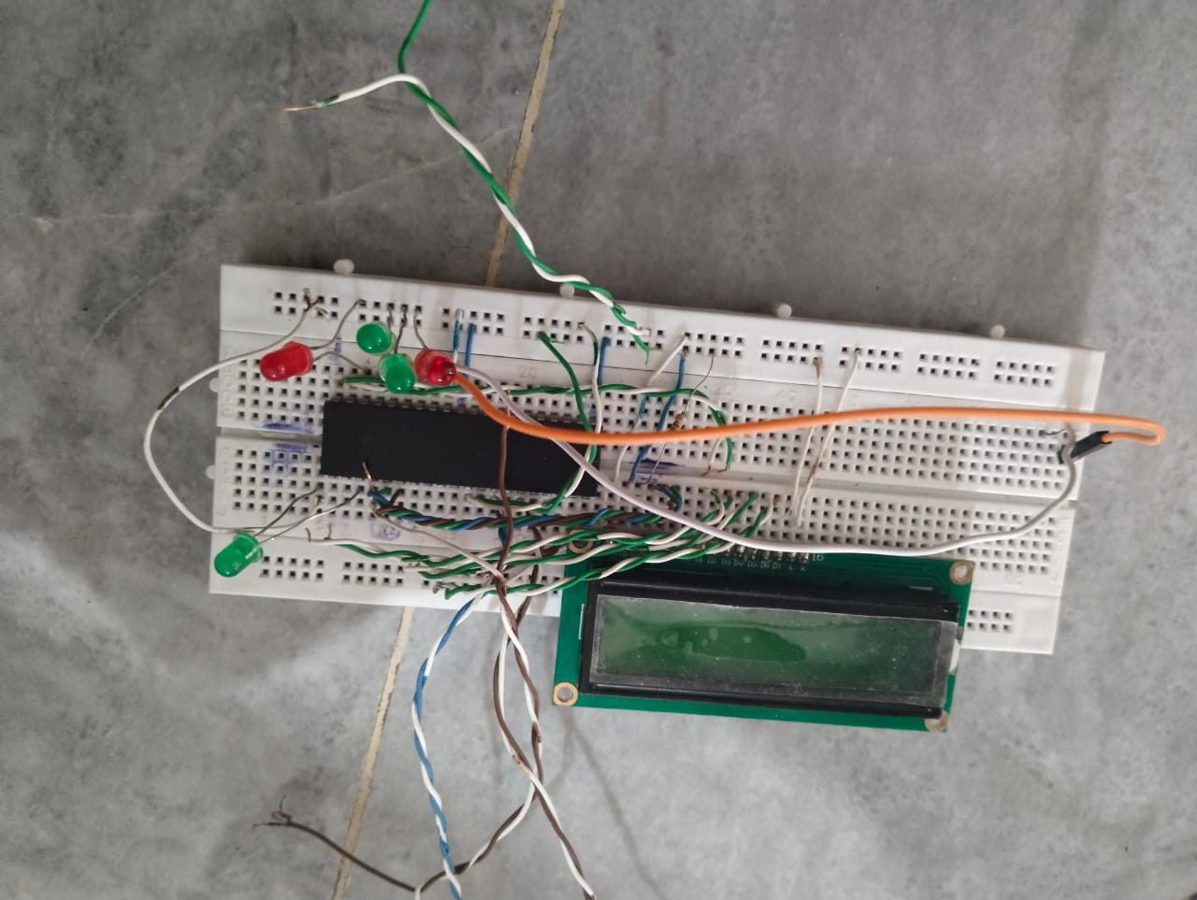

Fig: 1.1 Hydroponic Cattle Feed Generator

* 1. **Objectives**
* To design a fully automatic hydroponic feed system.
* To enhance control through assembly-programmed microcontroller.
* To integrate sensors and actuators with reliable performance.
* To enable timing precision for watering and tray movements.
  1. **Features and Cost Estimate of our Project**

**Features:**

* Real-time monitoring.
* Visual alert on LCD.
* Threshold-based activation.

**Estimated Cost:**

* MQ-2 Sensor: PKR 600
* PIC18F452: PKR 2500
* LCD (16x2): PKR 400
* LED (4): 100
* Miscellaneous (wires, breadboard): PKR 800

**Total Estimated Cost:** PKR 4400

# Literature Survey

Various automated farming systems have been proposed using microcontrollers and IoT modules. However, hydroponic automation using PIC18F452 with full assembly programming is less common. This project fills that gap with a resource-efficient solution. Hydroponic fodder systems typically use sensors for water levels and motorized systems for tray shifting. Integrating all modules under precise control using PIC18F452 enables cost-effective and scalable development.

* 1. **Microcontroller-Based Safety Systems**  
     Embedded systems utilizing PIC microcontrollers provide reliable processing and easy integration of sensors and actuators.

# Proposed Methodology

* 1. **Mathematical Model**

N/A

* 1. **System Design / Block diagram**

N/A

# Fig: 3.1 System Design

* 1. **Simulation/hardware model (if any)**



# Fig: 3.2 Hardware model

* 1. **Circuit diagram / components / simulation diagram (if any)**

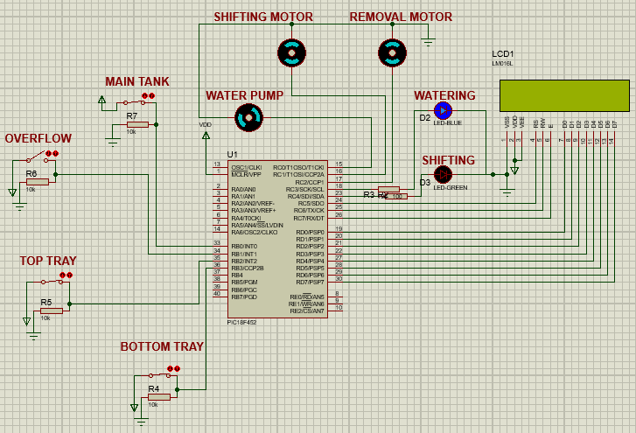

# Fig: 3.3 Simulation Diagram

* 1. **Flow chart / Pseudocode / Algorithm … (if any)**

**Flow Chart:**

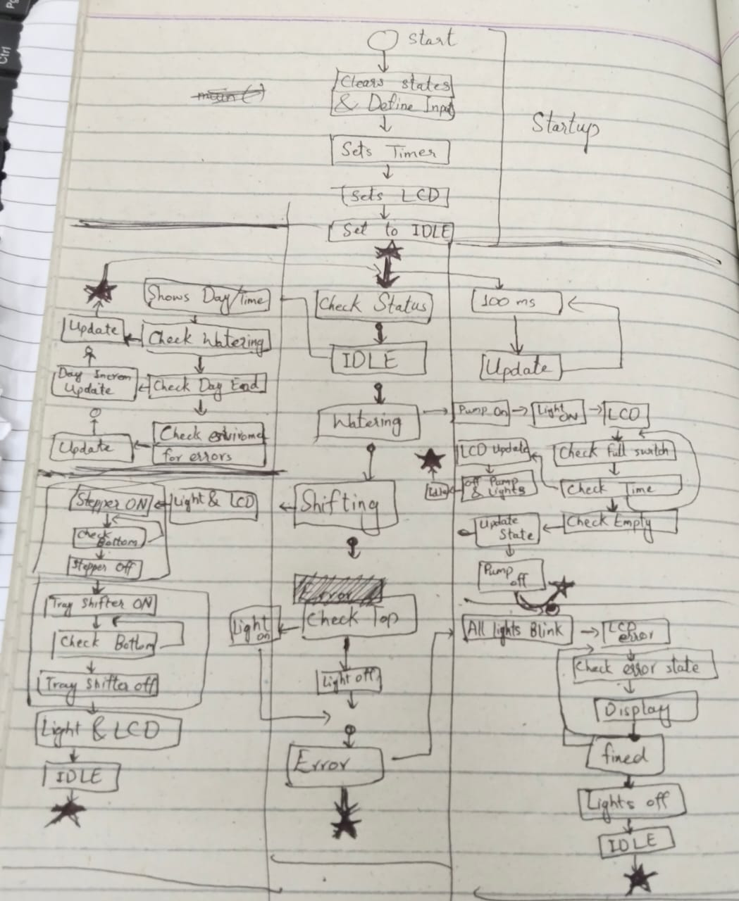

# Fig: 3.4 Flow Chart Diagram

# Simulation Results

* 1. **Hardware/software simulation results**

Figures should be properly numbered and with proper captions

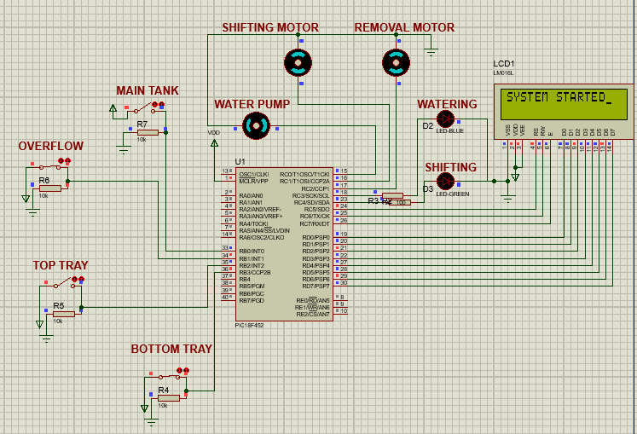

# Fig: 4.1 simulation results1

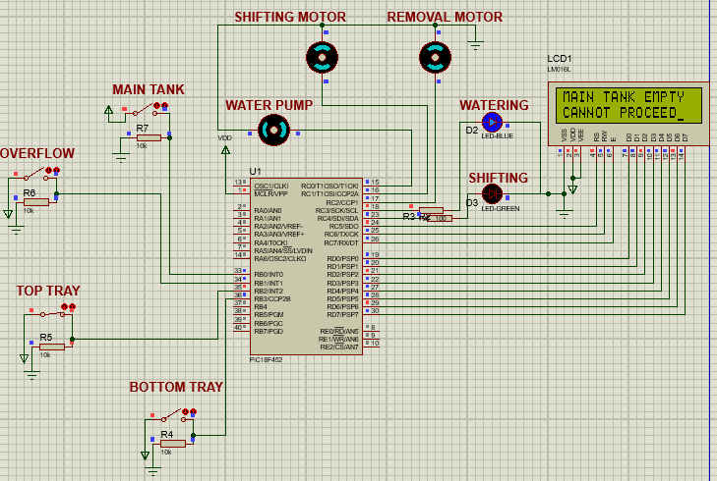

# Fig: 4.2 simulation results2

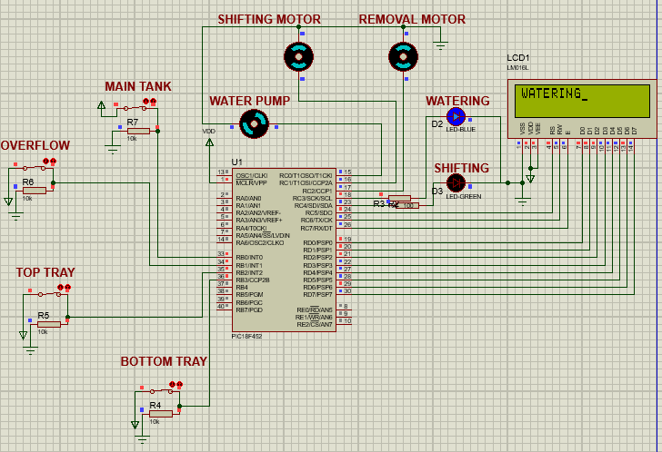

# Fig: 4.3 simulation results3

# Fig: 4.4 simulation results4

**Fig: 4.5 simulation results5**

* 1. **Design / simulation parameters**

**N/A**

* 1. **Comparison with Analytical Solution (if any)**

**Alternative Solutions:**

**1. Traditional Soil-Based Fodder Farming**

**-** Why not? Requires more land, water, time (7–8 weeks vs. 7 days), and is vulnerable to weather/disease.

**2. Commercial Feed Pellets**

**-** Why not? Expensive, processed, lacks freshness/natural enzymes, may have preservatives.

**Why You Chose Hydroponic System:**

- **Fast Growth:** Ready in 7 days.

- **Water-Efficient:** Uses 80–90% less water than traditional farming.

**- No Soil Needed:** Can be used in any climate or location.

**- Space-Saving:** Vertical trays allow small-area production.

**- Clean & Nutritious:** Fresh, chemical-free, enzyme-rich feed.

* 1. **Discussions etc…**

Simulation validated functionality before hardware implementation.

# Conclusions

The Automated Hydroponic Cattle Feed Generator efficiently demonstrates embedded control of a hydroponic system using PIC18F452. Implemented entirely in assembly language, the system provides precise timing, reliable automation, and scalability. With consistent tray shifting and timely watering cycles, this prototype showcases practical embedded system design for sustainable agriculture.

# References

Should be in standard IEEE format…

[1] Microchip Technology, "PIC18F452 Datasheet," <https://www.microchip.com/wwwproducts/en/PIC18F452>

[2] Microchip Technology, "MPLAB X IDE Documentation," https://www.microchip.com/mplab/mplab-x-ide

# Appendix

LIST P=PIC1F452, F=INHX32, N=0, ST=OFF, R=HEX

config OSC=HS, OSCS=OFF, WDT=OFF, BORV=45, PWRT=ON, BOR=ON, DEBUG=OFF,LVP=OFF, STVR=OFF

#INCLUDE P18F452.INC

ORG 00H

GOTO MAIN

;-------------------------------------------

ORG 08H

GOTO HIGH_ISR

;-------------------------------------------

ORG 2AH

MAIN

;---------------FILE REGISTERS--------------

STATUS_TEMP_SAVE EQU 20H

WREG_TEMP_SAVE EQU 21H

BSR_TEMP_SAVE EQU 22H

CURRENT_STATE EQU 23H

WATERING_COUNTER EQU 24H

DAY_COUNTER_L EQU 25H

DAY_COUNTER_H EQU 26H

;---------------INPUT LABELS----------------

INPUTS EQU PORTB

WATER_LEVEL_LOW EQU RB0

WATER_OVERFLOW EQU RB1

TRAY_TOP EQU RB2

TRAY_BOTTOM EQU RB3

;---------------OUTPUT LABELS---------------

OUTPUTS EQU PORTC

WATER_PUMP EQU RC0

SHIFTING_MOTOR EQU RC1

REMOVAL_MOTOR EQU RC2

LED_WATERING EQU RC3

LED_SHIFTING EQU RC4

LCD_DATA EQU PORTD

LCD_RS EQU RC5

LCD_RW EQU RC6

LCD_EN EQU RC7

;----------------I/O SETTING----------------

SETF TRISB

CLRF TRISC

CLRF TRISD

;----------------PIC STATES-----------------

IDLE EQU 00H

WATERING EQU 01H

SHIFTING EQU 02H

;===========================================

;-----SETTING TIMER FOR 8.3s INTERRUPTS-----

MOVLW B'00000110'

MOVWF T0CON

CLRF TMR0H

CLRF TMR0L

BCF INTCON,TMR0IF

BSF INTCON,TMR0IE

BSF INTCON,GIE

BSF T0CON,TMR0ON

;---------CLEARING VARIABLES FIRST TIME-----

CLRF CURRENT_STATE

CLRF WATERING_COUNTER

CLRF DAY_COUNTER_L

CLRF DAY_COUNTER_H

;-------------------------------------------

CALL LCD_INIT

;DISPLAYING OPENING MESSAGE

CALL DISPLAY_STARTING_MESSAGE

CALL WAIT

;================MAIN LOOP==================

MAIN_LOOP

BCF OUTPUTS,LED_WATERING

BCF OUTPUTS,LED_SHIFTING

MOVF CURRENT_STATE, W

XORLW IDLE

BTFSC STATUS,Z

GOTO IDLE_STATE

MOVF CURRENT_STATE,W

XORLW WATERING

BTFSC STATUS,Z

GOTO WATERING_STATE

MOVF CURRENT_STATE,W

XORLW SHIFTING

BTFSC STATUS,Z

GOTO SHIFTING_STATE

GOTO MAIN_LOOP

;===========================================

IDLE_STATE

; Check Main Tank Empty

;BEING ON MEANS WATER LEVEL IS HIGHER THAN THIS

BTFSS INPUTS,WATER_LEVEL_LOW

GOTO DISPLAY_TANK_EMPTY

; Check for Top Tray Missing

BTFSC INPUTS,TRAY_TOP

GOTO L1

CALL DISPLAY_TOP_MISSING

GOTO L2

L1

CALL DISPLAY_IDLE_MESSAGE

L2

; EVERYTHING IS OK, proceed

BCF OUTPUTS,LED_WATERING

BCF OUTPUTS,LED_SHIFTING

CALL CHECK_PUMP_TIMER

MOVLW WATERING

CPFSEQ CURRENT_STATE

CALL CHECK_DAY_TIMER

GOTO MAIN_LOOP

;-----------------------------------------

CHECK_PUMP_TIMER

;SINCE 15*8s=120s OR 2 min

MOVF WATERING_COUNTER,W

SUBLW 04H ; 0x0F - WATERING_COUNTER

BTFSC STATUS,C ; If C=1, then literal >= WREG

RETURN

MOVLW WATERING

MOVWF CURRENT_STATE

RETURN

;------------------------------------------

CHECK_DAY_TIMER

;42*256 + 48 = 10800*8 = 24 hours

;MOVLW 29H

;CPFSGT DAY_COUNTER_H

;GOTO MAIN_LOOP

;MOVLW 2FH

;CURRENTLY USING ONLY 6 MINUTES TIMER

MOVLW 08H

CPFSGT DAY_COUNTER_L

RETURN

MOVLW SHIFTING

MOVWF CURRENT_STATE

CLRF DAY_COUNTER_H

CLRF DAY_COUNTER_L

RETURN

;-------------------------------------------

WATERING_STATE

BTFSS INPUTS,WATER_LEVEL_LOW

GOTO DISPLAY_TANK_EMPTY

BCF OUTPUTS,LED_SHIFTING

BSF OUTPUTS,LED_WATERING

BSF OUTPUTS,WATER_PUMP

WATERING_IN_PROGRESS

CALL DISPLAY_WATERING

BTFSC INPUTS,WATER_OVERFLOW

GOTO WATERING_DONE

BTFSC INPUTS,WATER_LEVEL_LOW

GOTO WATERING_IN_PROGRESS

BCF OUTPUTS,WATER_PUMP

MOVLW IDLE

MOVWF CURRENT_STATE

GOTO DISPLAY_TANK_EMPTY

WATERING_DONE

BCF OUTPUTS,WATER_PUMP

CALL DISPLAY_WATERING_DONE

CLRF WATERING_COUNTER

MOVLW IDLE

MOVWF CURRENT_STATE

GOTO MAIN_LOOP

;-------------------------------------------

SHIFTING_STATE

BSF OUTPUTS,LED_SHIFTING

BTFSS INPUTS,TRAY_BOTTOM

GOTO SHIFT_DOWN

CALL DISPLAY_TRAY_REMOVAL

BSF OUTPUTS,REMOVAL_MOTOR

REMOVAL_IN_PROGRESS BTFSC INPUTS,TRAY_BOTTOM

GOTO REMOVAL_IN_PROGRESS

BCF OUTPUTS, REMOVAL_MOTOR

SHIFT_DOWN

CALL DISPLAY_TRAY_SHIFTING

BSF OUTPUTS,SHIFTING_MOTOR

SHIFTING_IN_PROGRESS BTFSS INPUTS,TRAY_BOTTOM

GOTO SHIFTING_IN_PROGRESS

BCF OUTPUTS,SHIFTING_MOTOR

CALL DISPLAY_SHIFTING_DONE

MOVLW IDLE

MOVWF CURRENT_STATE

GOTO MAIN_LOOP

;===========================================

TOGGLE

BTG OUTPUTS,LED_WATERING

BTG OUTPUTS,LED_SHIFTING

RETURN

;===========================================

LCD_INIT

BCF OUTPUTS,LCD_EN

CALL LDELAY

MOVLW 38H

CALL WRT_INS

CALL LDELAY

MOVLW 0EH ;DISPLAY ON, CULCD_RSOR ON

CALL WRT_INS

CALL LDELAY

RETURN

;-------------------------------------------

CLEAR_SCREEN

MOVLW 01H ;CLEALCD_RS THE SCRELCD_EN

CALL WRT_INS

CALL DELAY

RETURN

;-------------------------------------------

SHIFT_CURSOR_RIGHT

MOVLW 06H ;SHIFTS CULCD_RSOR RIGHT

CALL WRT_INS

CALL DELAY

RETURN

;-------------------------------------------

LINE_1_START

MOVLW 80H ;CURSOR AT LINE 1 POS 0

CALL WRT_INS

CALL DELAY

RETURN

;-------------------------------------------

LINE_2_START

MOVLW 0xC0 ; CURSOR AT LINE 2 POSITION 0

CALL WRT_INS

CALL DELAY

RETURN

;-------------------------------------------

WRT_INS

MOVWF LCD_DATA

BCF OUTPUTS,LCD_RS

BCF OUTPUTS,LCD_RW

BSF OUTPUTS,LCD_EN

CALL SDELAY

BCF OUTPUTS,LCD_EN

RETURN

;-------------------------------------------

WRT_DATA

MOVWF LCD_DATA

BSF OUTPUTS,LCD_RS

BCF OUTPUTS,LCD_RW

BSF OUTPUTS,LCD_EN

CALL SDELAY

BCF OUTPUTS,LCD_EN

RETURN

;===========================================

;-------------STARTING MESSAGE--------------

DISPLAY_STARTING_MESSAGE

CALL CLEAR_SCREEN

CALL SHIFT_CURSOR_RIGHT

CALL LINE_1_START

MOVLW A'S'

CALL WRT_DATA

CALL DELAY

MOVLW A'Y'

CALL WRT_DATA

CALL DELAY

MOVLW A'S'

CALL WRT_DATA

CALL DELAY

MOVLW A'T'

CALL WRT_DATA

CALL DELAY

MOVLW A'E'

CALL WRT_DATA

CALL DELAY

MOVLW A'M'

CALL WRT_DATA

CALL DELAY

MOVLW A' '

CALL WRT_DATA

CALL DELAY

MOVLW A'S'

CALL WRT_DATA

CALL DELAY

MOVLW A'T'

CALL WRT_DATA

CALL DELAY

MOVLW A'A'

CALL WRT_DATA

CALL DELAY

MOVLW A'R'

CALL WRT_DATA

CALL DELAY

MOVLW A'T'

CALL WRT_DATA

CALL DELAY

MOVLW A'E'

CALL WRT_DATA

CALL DELAY

MOVLW A'D'

CALL WRT_DATA

CALL DELAY

RETURN

;---------------IDLE STATE MESSAGE----------

DISPLAY_IDLE_MESSAGE

CALL CLEAR_SCREEN

CALL SHIFT_CURSOR_RIGHT

CALL LINE_1_START

MOVLW A'I'

CALL WRT_DATA

CALL DELAY

MOVLW A'D'

CALL WRT_DATA

CALL DELAY

MOVLW A'L'

CALL WRT_DATA

CALL DELAY

MOVLW A'E'

CALL WRT_DATA

CALL DELAY

MOVLW A' '

CALL WRT_DATA

CALL DELAY

MOVLW A'S'

CALL WRT_DATA

CALL DELAY

MOVLW A'T'

CALL WRT_DATA

CALL DELAY

MOVLW A'A'

CALL WRT_DATA

CALL DELAY

MOVLW A'T'

CALL WRT_DATA

CALL DELAY

MOVLW A'E'

CALL WRT_DATA

CALL DELAY

RETURN

;---------------MAIN TANK EMPTY-------------

DISPLAY_TANK_EMPTY

BCF OUTPUTS,LED_WATERING

BSF OUTPUTS,LED_SHIFTING

CALL CLEAR_SCREEN

CALL SHIFT_CURSOR_RIGHT

CALL LINE_1_START

MOVLW A'M'

CALL WRT_DATA

CALL TOGGLE

CALL DELAY

MOVLW A'A'

CALL WRT_DATA

CALL TOGGLE

CALL DELAY

MOVLW A'I'

CALL WRT_DATA

CALL TOGGLE

CALL DELAY

MOVLW A'N'

CALL WRT_DATA

CALL TOGGLE

CALL DELAY

MOVLW A' '

CALL WRT_DATA

CALL TOGGLE

CALL DELAY

MOVLW A'T'

CALL WRT_DATA

CALL TOGGLE

CALL DELAY

MOVLW A'A'

CALL WRT_DATA

CALL TOGGLE

CALL DELAY

MOVLW A'N'

CALL WRT_DATA

CALL TOGGLE

CALL DELAY

MOVLW A'K'

CALL WRT_DATA

CALL TOGGLE

CALL DELAY

MOVLW A' '

CALL WRT_DATA

CALL TOGGLE

CALL DELAY

MOVLW A'E'

CALL WRT_DATA

CALL TOGGLE

CALL DELAY

MOVLW A'M'

CALL WRT_DATA

CALL TOGGLE

CALL DELAY

MOVLW A'P'

CALL WRT_DATA

CALL TOGGLE

CALL DELAY

MOVLW A'T'

CALL WRT_DATA

CALL TOGGLE

CALL DELAY

MOVLW A'Y'

CALL WRT_DATA

CALL TOGGLE

CALL DELAY

CALL SHIFT_CURSOR_RIGHT

CALL LINE_2_START

MOVLW A'C'

CALL WRT_DATA

CALL TOGGLE

CALL DELAY

MOVLW A'A'

CALL WRT_DATA

CALL TOGGLE

CALL DELAY

MOVLW A'N'

CALL WRT_DATA

CALL TOGGLE

CALL DELAY

MOVLW A'N'

CALL WRT_DATA

CALL TOGGLE

CALL DELAY

MOVLW A'O'

CALL WRT_DATA

CALL TOGGLE

CALL DELAY

MOVLW A'T'

CALL WRT_DATA

CALL TOGGLE

CALL DELAY

MOVLW A' '

CALL WRT_DATA

CALL TOGGLE

CALL DELAY

MOVLW A'P'

CALL WRT_DATA

CALL TOGGLE

CALL DELAY

MOVLW A'R'

CALL WRT_DATA

CALL TOGGLE

CALL DELAY

MOVLW A'O'

CALL WRT_DATA

CALL TOGGLE

CALL DELAY

MOVLW A'C'

CALL WRT_DATA

CALL TOGGLE

CALL DELAY

MOVLW A'E'

CALL WRT_DATA

CALL TOGGLE

CALL DELAY

MOVLW A'E'

CALL WRT_DATA

CALL TOGGLE

CALL DELAY

MOVLW A'D'

CALL WRT_DATA

CALL TOGGLE

CALL DELAY

GOTO MAIN_LOOP

;---------------TOP IS MISSING--------------

DISPLAY_TOP_MISSING

BCF OUTPUTS,LED_WATERING

BSF OUTPUTS,LED_SHIFTING

CALL CLEAR_SCREEN

CALL SHIFT_CURSOR_RIGHT

CALL LINE_1_START

MOVLW A'N'

CALL WRT_DATA

CALL TOGGLE

CALL DELAY

MOVLW A'O'

CALL WRT_DATA

CALL TOGGLE

CALL DELAY

MOVLW A' '

CALL WRT_DATA

CALL TOGGLE

CALL DELAY

MOVLW A'T'

CALL WRT_DATA

CALL TOGGLE

CALL DELAY

MOVLW A'O'

CALL WRT_DATA

CALL TOGGLE

CALL DELAY

MOVLW A'P'

CALL WRT_DATA

CALL TOGGLE

CALL DELAY

MOVLW A' '

CALL WRT_DATA

CALL TOGGLE

CALL DELAY

MOVLW A'T'

CALL WRT_DATA

CALL TOGGLE

CALL DELAY

MOVLW A'R'

CALL WRT_DATA

CALL TOGGLE

CALL DELAY

MOVLW A'A'

CALL WRT_DATA

CALL TOGGLE

CALL DELAY

MOVLW A'Y'

CALL WRT_DATA

CALL TOGGLE

CALL DELAY

RETURN

;--------------DISPLAYING WATERING----------

DISPLAY_WATERING

CALL CLEAR_SCREEN

CALL SHIFT_CURSOR_RIGHT

CALL LINE_1_START

MOVLW A'W'

CALL WRT_DATA

CALL DELAY

MOVLW A'A'

CALL WRT_DATA

CALL DELAY

MOVLW A'T'

CALL WRT_DATA

CALL DELAY

MOVLW A'E'

CALL WRT_DATA

CALL DELAY

MOVLW A'R'

CALL WRT_DATA

CALL DELAY

MOVLW A'I'

CALL WRT_DATA

CALL DELAY

MOVLW A'N'

CALL WRT_DATA

CALL DELAY

MOVLW A'G'

CALL WRT_DATA

CALL DELAY

RETURN

;---------DISPLAYING WATERING DONE----------

DISPLAY_WATERING_DONE

CALL CLEAR_SCREEN

CALL SHIFT_CURSOR_RIGHT

CALL LINE_1_START

MOVLW A'W'

CALL WRT_DATA

CALL TOGGLE

CALL DELAY

MOVLW A'A'

CALL WRT_DATA

CALL TOGGLE

CALL DELAY

MOVLW A'T'

CALL WRT_DATA

CALL TOGGLE

CALL DELAY

MOVLW A'E'

CALL WRT_DATA

CALL TOGGLE

CALL DELAY

MOVLW A'R'

CALL WRT_DATA

CALL TOGGLE

CALL DELAY

MOVLW A'I'

CALL WRT_DATA

CALL TOGGLE

CALL DELAY

MOVLW A'N'

CALL WRT_DATA

CALL TOGGLE

CALL DELAY

MOVLW A'G'

CALL WRT_DATA

CALL TOGGLE

CALL DELAY

MOVLW A' '

CALL WRT_DATA

CALL TOGGLE

CALL DELAY

MOVLW A'D'

CALL WRT_DATA

CALL TOGGLE

CALL DELAY

MOVLW A'O'

CALL WRT_DATA

CALL TOGGLE

CALL DELAY

MOVLW A'N'

CALL WRT_DATA

CALL TOGGLE

CALL DELAY

MOVLW A'E'

CALL WRT_DATA

CALL TOGGLE

CALL DELAY

RETURN

;--------DISPLAYING TRAY REMOVAL----------

DISPLAY_TRAY_REMOVAL

CALL CLEAR_SCREEN

CALL SHIFT_CURSOR_RIGHT

CALL LINE_1_START

MOVLW A'R'

CALL WRT_DATA

CALL DELAY

MOVLW A'E'

CALL WRT_DATA

CALL DELAY

MOVLW A'M'

CALL WRT_DATA

CALL DELAY

MOVLW A'O'

CALL WRT_DATA

CALL DELAY

MOVLW A'V'

CALL WRT_DATA

CALL DELAY

MOVLW A'I'

CALL WRT_DATA

CALL DELAY

MOVLW A'N'

CALL WRT_DATA

CALL DELAY

MOVLW A'G'

CALL WRT_DATA

CALL DELAY

MOVLW A' '

CALL WRT_DATA

CALL DELAY

MOVLW A'B'

CALL WRT_DATA

CALL DELAY

MOVLW A'O'

CALL WRT_DATA

CALL DELAY

MOVLW A'T'

CALL WRT_DATA

CALL DELAY

MOVLW A'T'

CALL WRT_DATA

CALL DELAY

MOVLW A'O'

CALL WRT_DATA

CALL DELAY

MOVLW A'M'

CALL WRT_DATA

CALL DELAY

MOVLW A' '

CALL WRT_DATA

CALL DELAY

MOVLW A'T'

CALL WRT_DATA

CALL DELAY

MOVLW A'R'

CALL WRT_DATA

CALL DELAY

MOVLW A'A'

CALL WRT_DATA

CALL DELAY

MOVLW A'Y'

CALL WRT_DATA

CALL DELAY

RETURN

;--------DISPLAYING TRAY SHIFTING-----------

DISPLAY_TRAY_SHIFTING

CALL CLEAR_SCREEN

CALL SHIFT_CURSOR_RIGHT

CALL LINE_1_START

MOVLW A'S'

CALL WRT_DATA

CALL DELAY

MOVLW A'H'

CALL WRT_DATA

CALL DELAY

MOVLW A'I'

CALL WRT_DATA

CALL DELAY

MOVLW A'F'

CALL WRT_DATA

CALL DELAY

MOVLW A'T'

CALL WRT_DATA

CALL DELAY

MOVLW A'I'

CALL WRT_DATA

CALL DELAY

MOVLW A'N'

CALL WRT_DATA

CALL DELAY

MOVLW A'G'

CALL WRT_DATA

CALL DELAY

MOVLW A' '

CALL WRT_DATA

CALL DELAY

MOVLW A'T'

CALL WRT_DATA

CALL DELAY

MOVLW A'R'

CALL WRT_DATA

CALL DELAY

MOVLW A'A'

CALL WRT_DATA

CALL DELAY

MOVLW A'Y'

CALL WRT_DATA

CALL DELAY

MOVLW A'S'

CALL WRT_DATA

CALL DELAY

RETURN

;---------DISPLAYING SHIFTING DONE----------

DISPLAY_SHIFTING_DONE

CALL CLEAR_SCREEN

CALL SHIFT_CURSOR_RIGHT

CALL LINE_1_START

MOVLW A'S'

CALL WRT_DATA

CALL TOGGLE

CALL DELAY

MOVLW A'H'

CALL WRT_DATA

CALL TOGGLE

CALL DELAY

MOVLW A'I'

CALL WRT_DATA

CALL TOGGLE

CALL DELAY

MOVLW A'F'

CALL WRT_DATA

CALL TOGGLE

CALL DELAY

MOVLW A'T'

CALL WRT_DATA

CALL TOGGLE

CALL DELAY

MOVLW A'I'

CALL WRT_DATA

CALL TOGGLE

CALL DELAY

MOVLW A'N'

CALL WRT_DATA

CALL TOGGLE

CALL DELAY

MOVLW A'G'

CALL WRT_DATA

CALL TOGGLE

CALL DELAY

MOVLW A' '

CALL WRT_DATA

CALL TOGGLE

CALL DELAY

MOVLW A'D'

CALL WRT_DATA

CALL TOGGLE

CALL DELAY

MOVLW A'O'

CALL WRT_DATA

CALL TOGGLE

CALL DELAY

MOVLW A'N'

CALL WRT_DATA

CALL TOGGLE

CALL DELAY

MOVLW A'E'

CALL WRT_DATA

CALL TOGGLE

CALL DELAY

RETURN

;===========================================

SDELAY

NOP

RETURN

;-------------------------------------------

LDELAY

;LETS HAVE 8ms DELAY USING TIMER 1

;T1C0N = 10000000

MOVLW 80H

MOVWF T1CON

; preload = 65536 - 8000 = 57536 = E0 C0h

MOVLW 0xE0

MOVWF TMR1H

MOVLW 0XC0

MOVWF TMR1L

BCF PIR1,TMR1IF

BSF T1CON,TMR1ON

CHK BTFSS PIR1,TMR1IF

GOTO CHK

BCF T1CON,TMR1ON

RETURN

;-------------------------------------------

DELAY

;LETS HAVE 250ms BETWEEN CHARACTERS

;USING PS 4

MOVLW B'10100000'

MOVWF T1CON

;preload = 65536 - 62500 = 3036 = 0B DC H

MOVLW 0x0B

MOVWF TMR1H

MOVLW 0xDC

MOVWF TMR1L

BCF PIR1,TMR1IF

BSF T1CON,TMR1ON

WAIT_DELAY BTFSS PIR1,TMR1IF

GOTO WAIT_DELAY

BCF T1CON,TMR1ON

RETURN

;----------WAITING FOR SOME TIME------------

WAIT

CALL DELAY

CALL DELAY

CALL DELAY

CALL DELAY

CALL DELAY

CALL DELAY

CALL DELAY

CALL DELAY

RETURN

;===========================================

HIGH_ISR

MOVWF WREG_TEMP_SAVE

MOVFF STATUS,STATUS_TEMP_SAVE

MOVFF BSR,BSR_TEMP_SAVE

BTFSS INTCON,TMR0IF

GOTO ISR_EXIT_RESTORE

;JUST FOR TESTING IF TIMER WORKS OR NOT

;BTG OUTPUTS,WATER_PUMP

BCF INTCON,TMR0IF

INCF WATERING_COUNTER,F

INCF DAY_COUNTER_L

BNZ ISR_EXIT_RESTORE

INCF DAY_COUNTER_H

ISR_EXIT_RESTORE

MOVFF BSR_TEMP_SAVE,BSR

MOVFF STATUS_TEMP_SAVE,STATUS

MOVF WREG_TEMP_SAVE,W

RETFIE

;===========================================

END

Teachers should assess CLO2, CLO3 and CLO4 based on the given rubrics

(overall weightage 20%)

Recommended Percentage Breakdown

|  |  |
| --- | --- |
| **CLO** | **Percentage** |
| CLO2 (Investigation) | 10% |
| CLO3 (Referencing/Citations)  *(Turnitin report should be generated.)* | 5% |
| CLO4 (Communication) | 5% |